SUMMER DAY CRUISE
Seaview Yacht Club – Monday 4 June 2018

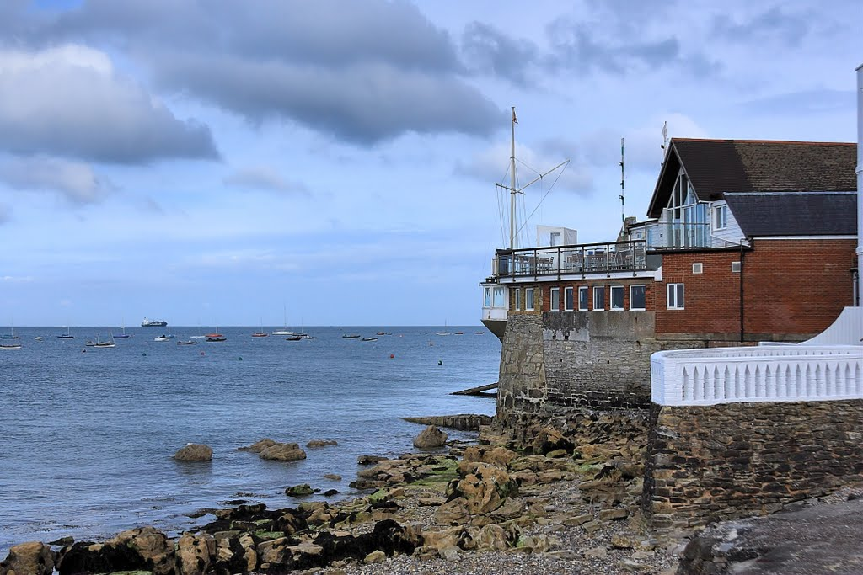

Seaview Yacht Club is celebrating its 125th Anniversary this year. Known for Mermaid sailing events and location on the north eastern shore of the Isle of Wight, it provides a great location for lunch. The sign-up list for the event is on our Club noticeboard and will close at 1200 on Friday 1 June, so that numbers and requirements can be passed to the club and contingency plans made in the event of bad weather.
HW Portsmouth is at 1607. Boats sailing from Lymington can expect a lift on the flood from 0830(L) allowing some 4 hours to make good the destination on the Eastern side of No Mans Land Fort. On arrival, boats should make fast to one of the Club’s mooring buoys and call for a lift from the RIBs which ferry visitors ashore. There will be a least 3m height of tide at the buoys.
Lunch will be available in the Clubhouse from the menu which changes daily.
The ebb tide runs Westerly at the forts from 1415 and boats should plan to leave no later than 1500, when the ebb runs in a south easterly direction. With reasonable winds the return voyage should be achievable by 1800.
There will be a briefing at the Club at 0800 on the 4th to update any changes to the plan, especially in light of the weather on the day, and allocate any spare crew to vessels. Listening watch: VHF Ch 72.
Alison Towler, Cruising Sub-committee: rlyc.cruisingsec@aol.co.uk; H 01590 673321.
Please remember that the decision to participate in events organised by the Club is the responsibility of the skipper of each participating boat. Experience of the skipper and crew and likely weather conditions are just some of the factors that skippers may need to consider when reaching such a decision.

