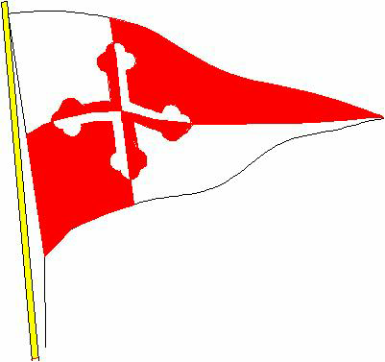
Chesapeake Bay Cruise 2019

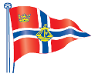

Following last Autumn’s successful cruise in the Solent, when we hosted members of the Sailing Club of Chesapeake, we have received an invitation for our members to make a return visit to sail in Chesapeake Bay.

The dates are Friday 13th to Monday 23rd September 2019.

The Chesapeake members plan to host us on their boats. Last year’s participants will have priority. If there are more of us than they can accommodate, members can charter their own out of Annapolis to join the cruise.

Outline of their plans :

- Dinner in the Annapolis Yacht Club on the 13th September
- A Hog roast on the Wye River at a member’s home
- A Cocktail party on the Corsica River
- An overnight in Rock Hall
- Two days in Baltimore
- A sail to Gibson Island to participate in team racing against
the Gibson Island Yacht Club - “Race for the Broom” event.
- Optional day trip to Washington DC on Monday 23rd

We invite you to contact us as soon as possible if you are interested. We holding a meeting for all interested in the club on Saturday 22nd September at 1100, when we hope to have more details.

Sue and Andrew Sutherland

suesutherland2014@gmail.com

