An invitation to rally at Vannes (South Brittany)
on the 14th and 15th July 2018
We would love to see you at Vannes, to experience the Fete Nationale Festival in this vibrant Southern Brittany City. Our rally starts with a pontoon party in the Port de Vannes (Marina) on the 14th July and we are planning to hold a lunch at a local restaurant on the 15th. (Like most businesses, including the Ports, they need to know the numbers before any commitment can be given and therefore we invite you to register your interest today).
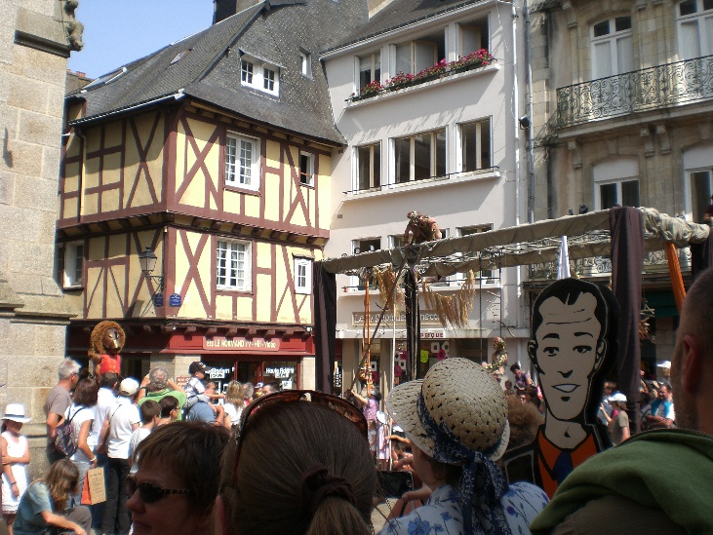
What is happening in Vannes? – If you have not been to the festival before then you have been missing a treat! The City hosts several vibrant parades throughout the day which culminate in a comprehensive firework display off the City Ramparts. It also hosts excellent markets, offering fresh produce, fish and meats, as well as lots of other ‘goodies’. Vannes has a medieval feel to it as you meander through the fascinating lanes within the City Ramparts, visiting the boutique shops.
Our rally proposes to enter the Port and ‘moor-up’ for 2 days on the 14th and 15th July.
What do you need to consider? – The Port de Vannes advise they will be very busy hosting the finale of the Ports du Morbihan Regatta on the 12th July and many boats are expected to stop-over for the 13th. The Capitainerie at Vannes suggests we enter the Port during the morning of the 14th, before the sill closes at 11 am, but to achieve this you will either need to get up very early in the morning, (if transiting the entrance to the Golfe du Morbihan that day) or, be moored/anchored near to Vannes on the 13th. The sill at Vannes re-opens at 7 pm.
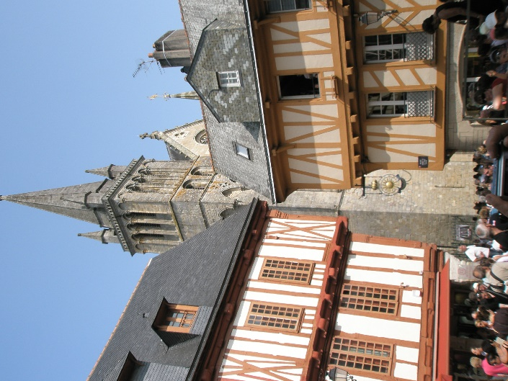
Those that fancy a leisurely approach can assemble at Crouesty Marina on the 12th and we have spoken to them requesting a group allocation of moorings. However, the Marina will not commit to this until we provide a list of Skippers, their Boat names and craft size. Should this arrangement go ahead, then it will allow for a bit of merriment during the evening of the 12th before transiting the entrance of the Morbihan during the afternoon of the 13th. If you haven’t transited before then be aware that there are several ‘tidal gates’ to consider, particularly as this weekend has significant Spring Tides (co-efficient 104). Further details will be provided when you register.
What do I do Next? – register your interest by email to yachttangaroa@btinternet.com and provide your name; boat name, its length and width; the anticipated number of crew on board; your contact details (mobile number); whether you are interested in attending the proposed lunch on the 15th and if you are likely to want a berth at Crouesty on the 12th July. Register early to help us get the best deal available.
We look forward to welcoming you.
Derek Barnard
Captain of the MOA France Atlantique Chapter and
Member of the Royal Lymington Cruising sub Committee

